Kitman Yiu (CIT185753)

Kitman200220022002@gmail.com

Introduction

The current documentation will explain what the project is, and how it will be accomplished. Explain the ultimate intended outcome of the project. This should serve as a brief introduction. Provide some background about the history of how the project got to this point.

PROJECT MANGAMENT PLAN

Horrible Game

(Preparation of Final Business Case)

Assignment 1

Due Date: 1/6/2015

# Communication Manager

Software for meeting is listed below

* Skype
* Team Viewer

Questions should be answered after meeting. The meeting we be hold once a week

* Are they on timeline?
* Are they doing the correct task?
* How much do they need to finish

More question will be apply upon if more issue has been investigate.

# Configuration Manager

The following folder structure will be applied during developing the game



The benefits for the folder structure are followed:

* I have been using quite a while
* No issued found
* Clear and fast for me to found out things that I need

# Cost Management

Please refer to Cost.pdf

# Human resource

C:\Users\Kitman\Desktop\Capture5.PNG

## Quest’s End Game

Background of Quest’s End Game are following

* AAA game companies in Australia Sydney.
* Have around 6 people in the company.
* Support by other AAA studio in Australia.
* All the employees have more than 10 years’ experience.
* employees been inside big companies or big games such as ea games and been making games such as need for speed

Following from the background above the following things they should able to help

* Game experience.
* The process of making a game.
* Teach me or give information to me that the things I’m don’t know about,
* Manage my time.
* How to go inside half brick

## Samarjit

Background of Sam Arjit are showed below:

* In testing environment more 10 years’ experience
* Have writing a lot of document
* Live in India
* Can speak really good English even he is India
* Cheap for hire

Outcome of Sam Arjit from the background above are list following

* Doing testing in games
* Writing testing document such as test cases and test plan in games
* Save me time for testing because I don’t need to do it.

# Quality Management

|  |
| --- |
| Milestone 1 (Will be filled at 4/8/2015) |
|  |
| Milestone 2 (Will be filled at 2/9/2015) |
|  |
| Milestone 3 (Will be filled at 4/9/2015) |

# Requirments Mangement

* Unity 5
* Photoshop
* Teamwork (project Management tool)
* Star Dock (Manage desktop tool)
* Skype
* Team viewer

Software Information and Reason for the software provide above

|  |
| --- |
| **Unity5** : Game engine which allows me to create the game |
| * I have been using it for a while so I’m good at it * It free for education use * Lot of examples and tutorial * Stabile don’t crash, not like unreal engine |
| **Photoshop:** A software allows me to create images |
| * Allow me create images * It supports almost every type of format * Easy to use * Popular tool * Lot of tutorials on YouTube * Less bugs |
| **Teamwork :** An online project management tool  **Star Dock :** An Desktop management tool |
| * Find information easily * Decreases my time to find information * Work my effecnly * Easy to use * Enough tutorials on YouTube to help me solve the problem * Less bugs |
| **Skype:** A software allow to chat to other people  **Team viewer :** A software allows other people control their computer |
| * Able to communicate to my team members * Easy to use * Less bugs * Enough tutorials on YouTube to help me solve the problem * Free * Most people use it |

# Risk Management

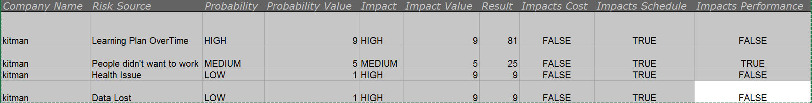

# Schedule AND SCOPE Management

## Work Breakdown STRUCTURE (WBS)

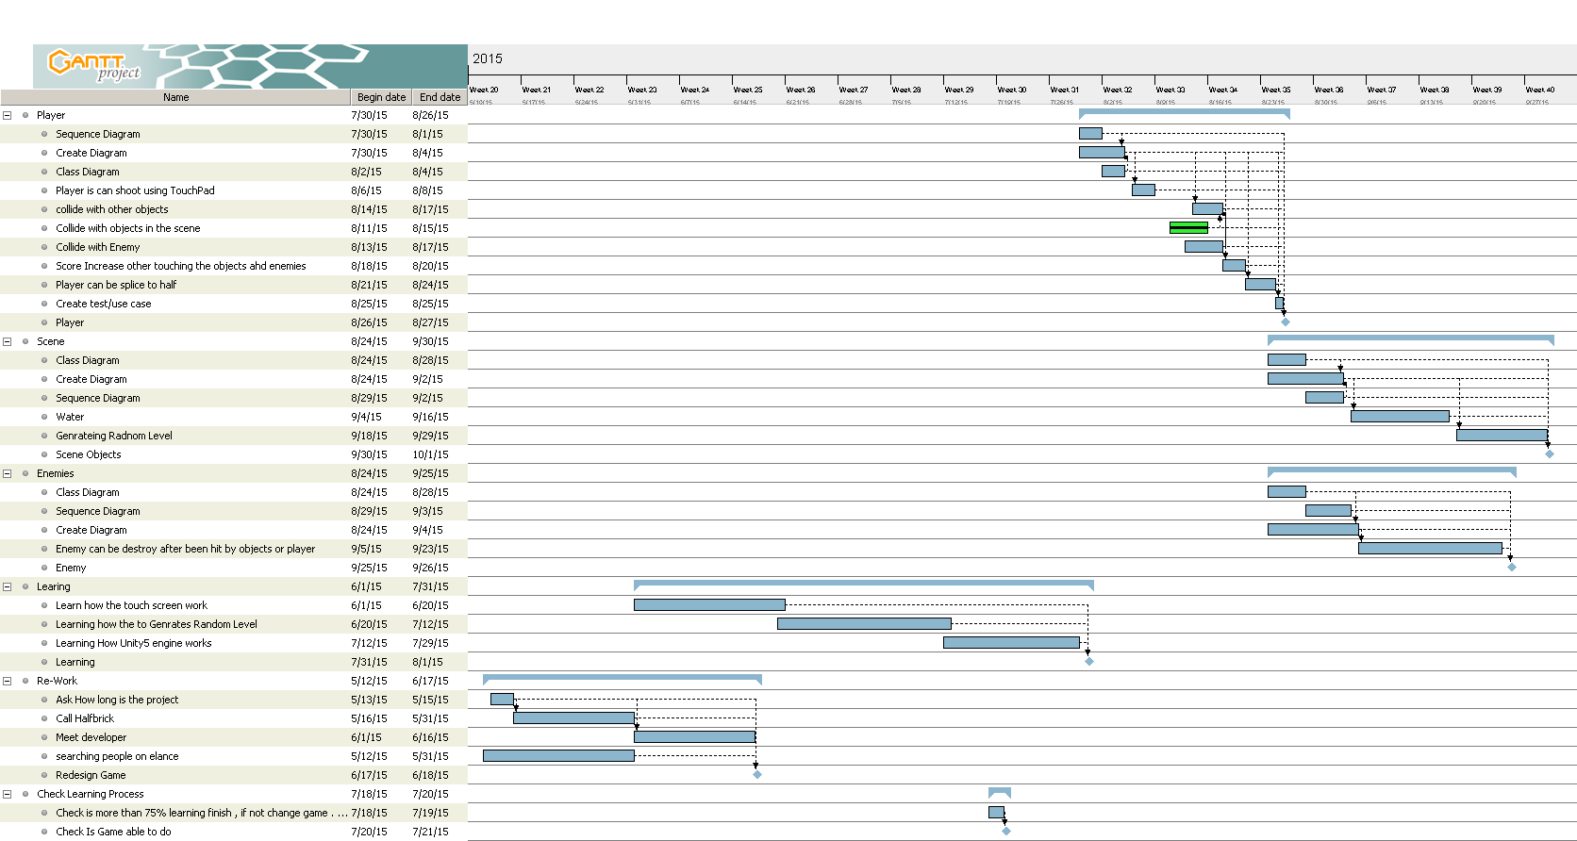

## Milestone

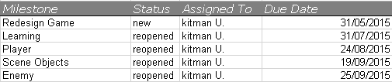

# Contingency plan

## Time

AUD

|  |  |
| --- | --- |
| When this plan be trigged? | 1 week behind the original plan |
| Impact Priority | Low |
| Action? | Reschedule the plan to able to catch up |
| Who will do? | Kitman |
| Budget? | 0$ |

|  |  |
| --- | --- |
| When this plan be trigged? | 2.5 weeks behind the original plan |
| Impact Priority | Medium |
| Action? | Reschedule the plan to able to catch up  Hire people if needed on Elance |
| Who will do? | Kitman |
| Budget? | $250 |

|  |  |
| --- | --- |
| When this plan be trigged? | 3 weeks behind the original plan |
| Impact Priority | High |
| Action? | Hire people and talk the AAA studio people  Reschedule the plan and cut down features |
| Who will do? | Kitman |
| Budget? | $500 |

|  |  |
| --- | --- |
| When this plan be trigged? | 3.5 weeks behind the original plan |
| Impact Priority | Emergent |
| Action? | Talk to teacher  Reschedule the plan and cut down features |
| Who will do? | Kitman |
| Budget? | $0 |

## COMMUNICATION

|  |  |
| --- | --- |
| When this plan be trigged? | Any team members won’t be able to work or behind schedule |
| Impact Priority | Emergent |
| Action? | Reschedule the plan and cut down features |
| Who will do? | Kitman |
| Budget? | $0 |

|  |  |
| --- | --- |
| When this plan be trigged? | Any team members quit the project |
| Impact Priority | Emergent |
| Action? | Reschedule the plan and decide whatever should hire another person |
| Who will do? | Kitman |
| Budget? | $0 |

|  |  |
| --- | --- |
| When this plan be trigged? | Team members was not following orders to do things |
| Impact Priority | Emergent |
| Action? | Fire the person.  Reschedule the plan and decide whatever should hire another person |
| Who will do? | Kitman |
| Budget? | $0 |

## Burget

|  |  |
| --- | --- |
| When this plan be trigged? | Budget spend more than expected |
| Impact Priority | Emergent |
| Action? | Every money spending we need to record by the following template as showed below |
| Who will do? | Kitman |
| Budget? | $0 |

### Money Template

|  |  |
| --- | --- |
| Budget? |  |
| Date? |  |
| Who? |  |
| How does it help myself to reach to goal? |  |
| How much time can it save you be spending this money? |  |
| Is there anyway can spend less money? |  |
| Feedback from people? |  |

## COMPUTER

|  |  |
| --- | --- |
| When this plan be trigged? | Data lost and A,B,C backup didn’t work |
| Impact Priority | Emergent |
| Action? | Talk to teacher |
| Who will do? | Kitman |
| Budget? | $0 |